# Azure Compute – Virtual Machines

## Objectives

In this hands-on lab, you will learn how to:

* Provision a Windows Server virtual machine in Azure
* Use a Desired State Configuration extension script to add WebDeploy and configure IIS
* Define a network security group rule to allow incoming HTTP and WebDeploy traffic
* Stop the virtual machine to suspend further usage charges

## **Prerequisites**

The following are required to complete this hands-on lab:

* An active Microsoft Azure subscription
* Visual Studio 2017 Community or greater (Professional or Enterprise)

## Exercises

This hands-on lab includes the following exercises:

* Exercise 1: Provision a virtual machine
* Exercise 2: Add a desired state configuration extension
* Exercise 3: Connect to the VM using RDP
* Exercise 4: Configure access for HTTP and WebDeploy ports
* Exercise 5: Create and deploy sample web application
* Exercise 6: Suspend the virtual machine

Estimated time to complete this lab: xx minutes

# Exercise 1: Provision a virtual machine

In this exercise, you will use the Azure Portal to create a virtual machine with Windows Server 2016 Datacenter.

1. Go the Azure Portal <https://portal.azure.com> and sign into your Azure account
2. Click the + New (or use the keyboard shortcut N) to open the **New blade**, then type **datacenter** into the search box and choose **Windows Server 2016 Datacenter**

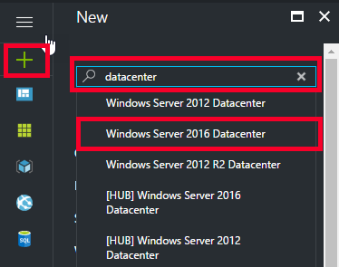

This will open the search results blade.

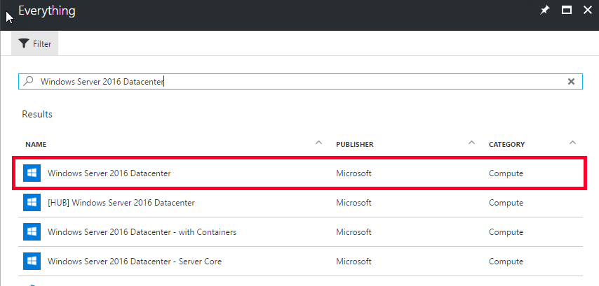

1. Select **Windows Server 2016 Datacenter**

This will show the information about the operating system and legal terms

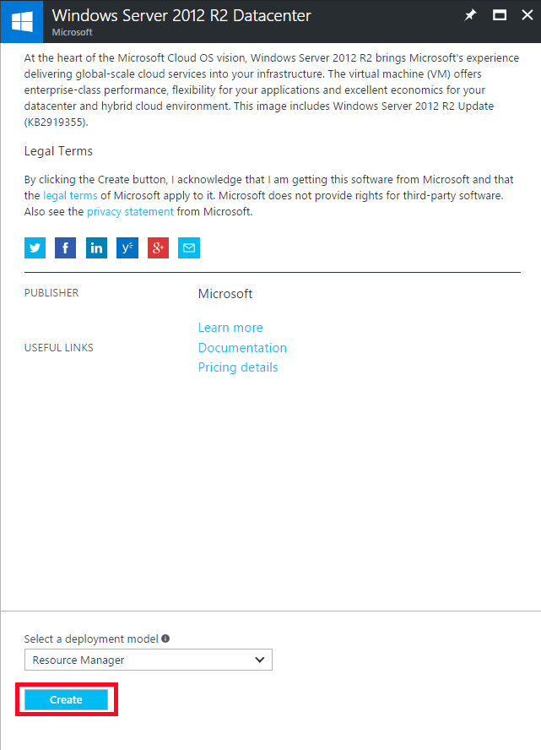

1. Leave the deployment model as the default of **Resource Manager** and **click the Create button**

This will open the Create Virtual Machine blade with the first step open to Basics.

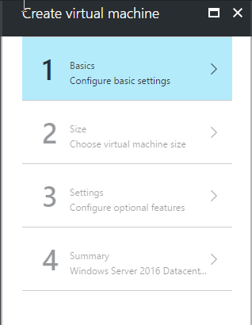

1. On the Basics blade, fill out the following selections:

* **Name:** GABVMLab<your first name>
* **VM disk type**: SSD
* **User name**: <your first name>
* **Password**: <a strong password minimum of 12 characters>
* **Confirm Password**: retype your password
* **Subscription**: choose your subscription
* **Resource Group**: Create new
  + Enter name of: GABVMLab
* **Location**: East US

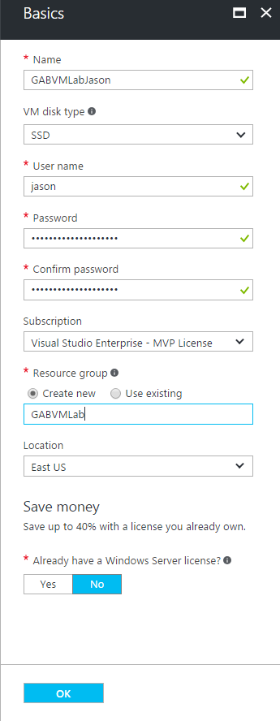

1. **Click the OK** button. This will open the next step
2. On the Choose a size blade, select **DS1_V2 Standard** and **click the Select** button

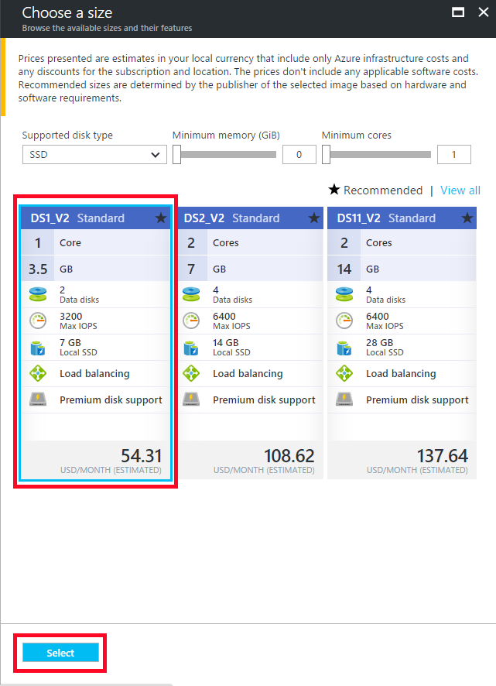

1. On the Settings blade, you can **leave all the default values** and **click the OK** button

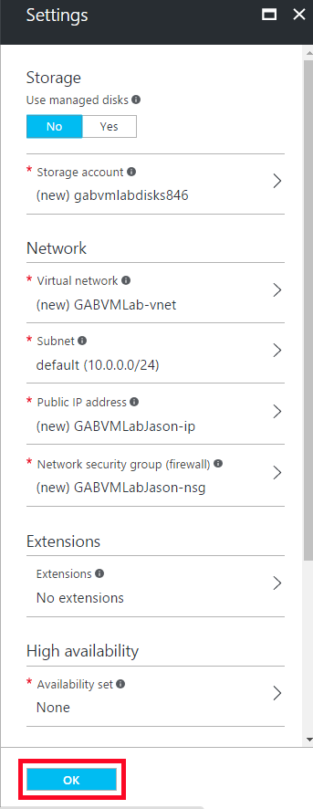

The **Summary** blade will now be showing all the selections you have made to create a virtual machine.

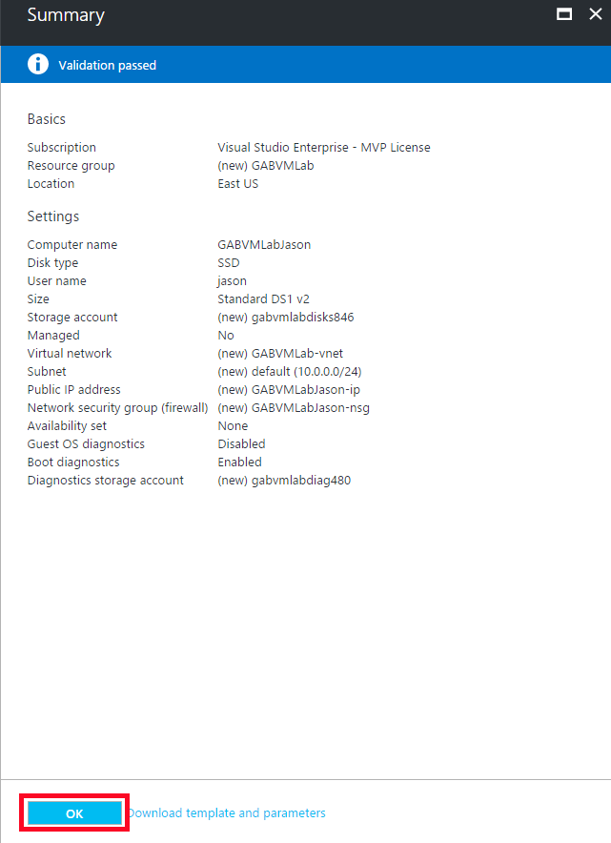

1. **Click the OK** button to start the provisioning of the new virtual machine

The provisioning should take 3 – 5 minutes to complete.

1. When the virtual machine is provisioned, the Overview blade for the VM should open. Click on the **GABVMLab** Resource Group link in the Essentials panel.

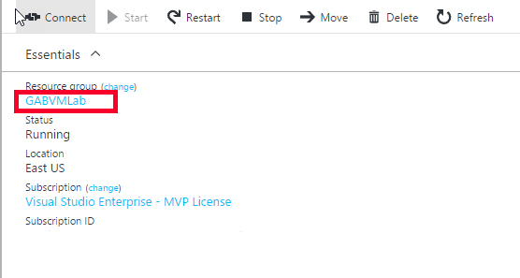

This will open the list of all the resources that were provisioned along with the creation of the virtual machine. These resources include 7 items:

* 2 storage accounts
* 1 virtual machine
* 1 network interface
* 1 public IP Address
* 1 network security group
* 1 virtual network

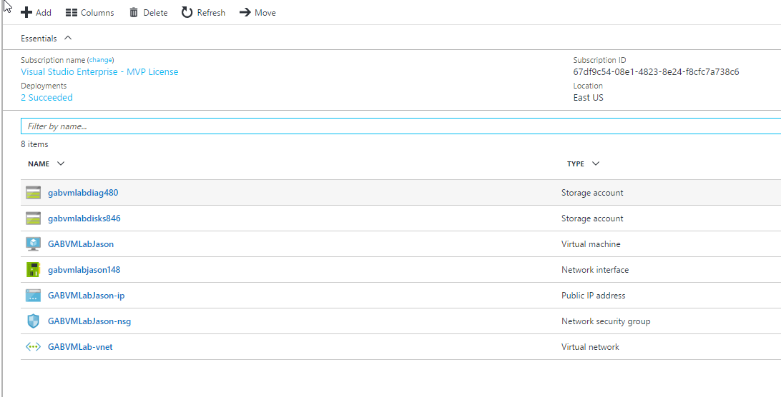

The VM is now running. The next step is to add IIS and WebDeploy – which can be done by adding an extension to the VM.

# Exercise 2: Add a desired state configuration extension

In this exercise you will add IIS and WebDeploy to the VM by using a virtual machine extension.

1. Open the VM blade you create in Exercise 1 and type **extension** into the search

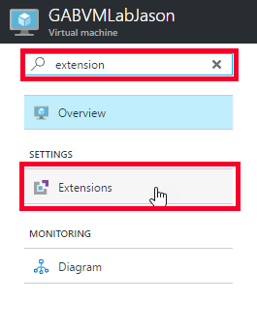

This will open the extensions blade.

1. Click the **+ Add** button, to get the **New resource** listing

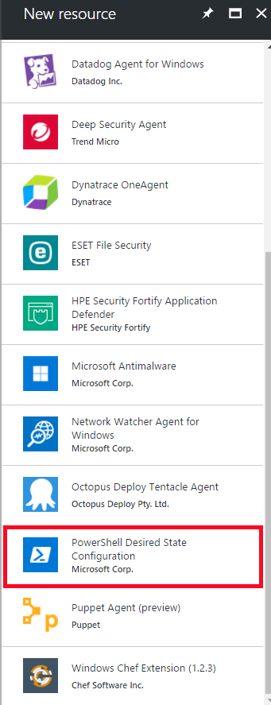

1. Find the **PowerShell Desired State Configuration** item and **click on it**

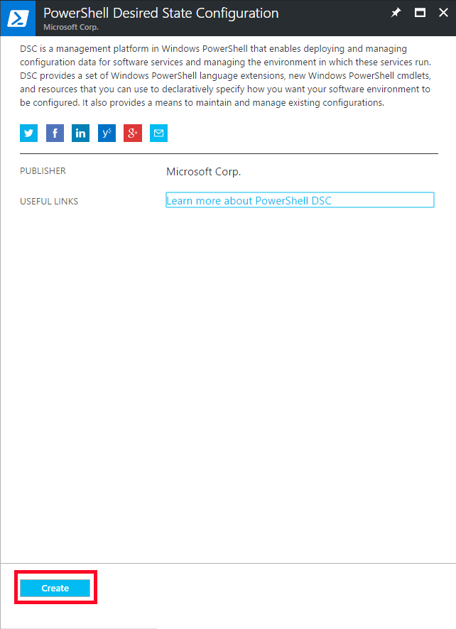

This opens the information blade.

1. Click the **Create** button, to get to the Install extension blade.
2. On the Install extension blade, fill out the following:

NOTE: You will need the ConfigureWebServer.ps1.zip file from :

* **Configuration Modules or Script:** Select the ConfigureWebServer.ps1.zip file
* **Module-qualified Name of Configuration:** ConfigureWebServer.ps1\Main
* **Configuration Arguments:** nodeName=<name of your vm>
* **Configuration Data PSD1 File:** leave blank
* **WMF Version:** latest
* **Data Collection:** Enable
* **Version:** 2.24
* **Auto Upgrade Minor Version:** Yes

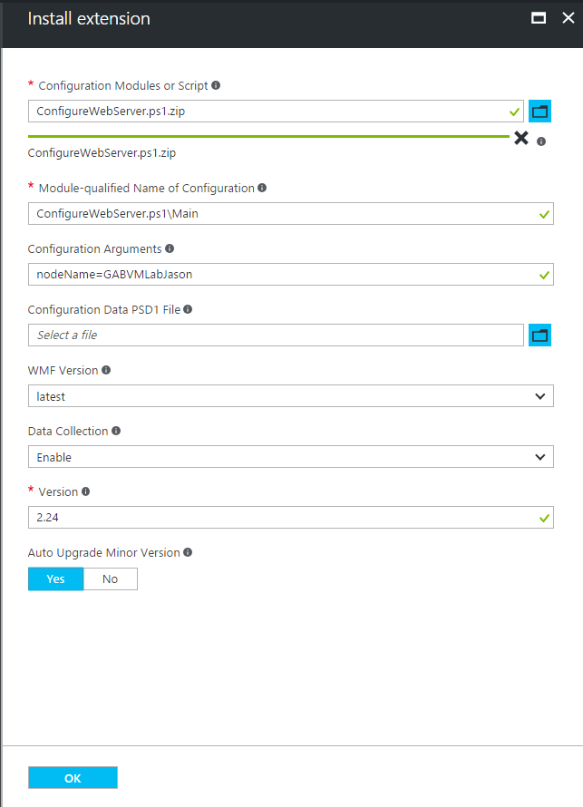

1. Click the **OK** button to start the deployment of the extension

The deployment may take 5-10 minutes to complete.

You can keep track of the status by going to the notifications blade (click on the bell icon in the upper right corner of the portal)



# Exercise 3: Connect to the VM using RDP

In this exercise, you will verify the IIS and WebDeploy extension by remotely connecting to the virtual machine.

1. Open the VM blade you create in Exercise 1 and click on the **Connect** button

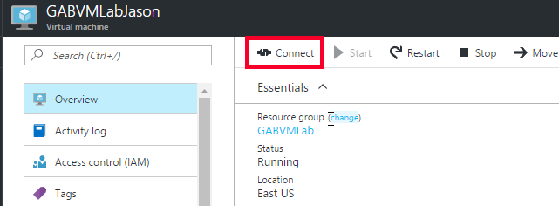

This will download the .rdp file and show the Remote Desktop Connection dialog

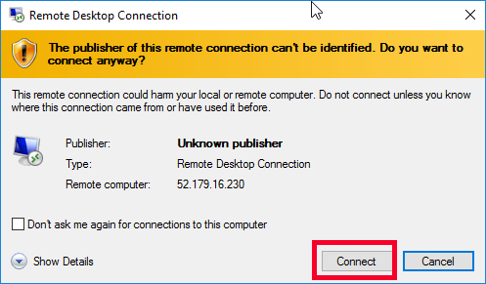

1. Click the **Connect** button

This will show the Windows Security dialog

1. If you have Windows 10, you will need to select the **More Choices** link and then select the **Use a different account** option
2. Enter the username and password you used when setting up the VM in exercise 1, step 5

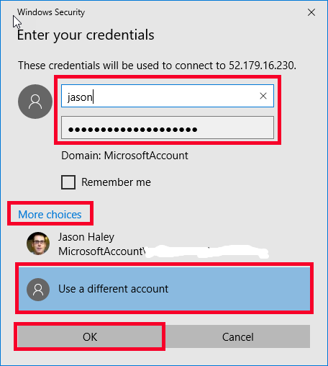

1. Click Ok

This will show the Remote Desktop Connection dialog

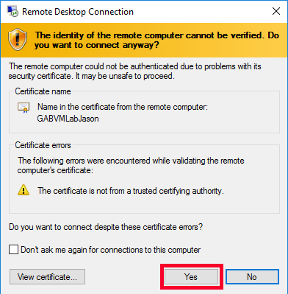

1. Click Yes to login to the machine

Once the desktop for the VM has come up, the Server Manager -> Dashboard should be showing

1. In the left pane of the Server Manager Dashboard, click on **IIS**

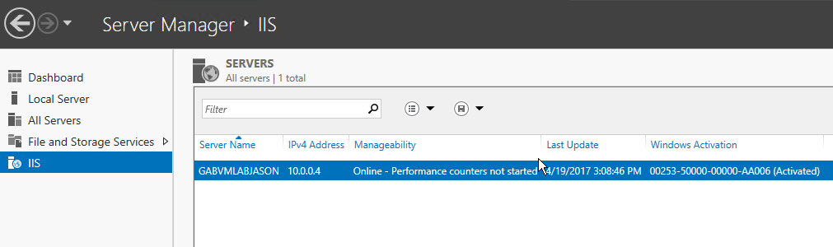

1. Right click on the server name in the listing and select Internet Information Services (IIS) Manager

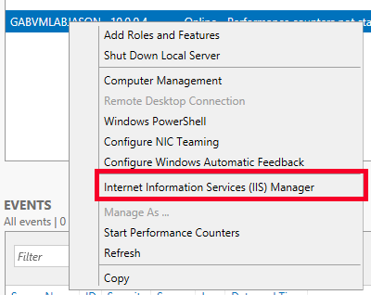

1. Once the IIS Manager is loaded, in the left pane – **expand the Machine node and the Sites** node.
2. Right click on **Default Web Site -> Deploy -> Configure Web Deploy Publishing…**

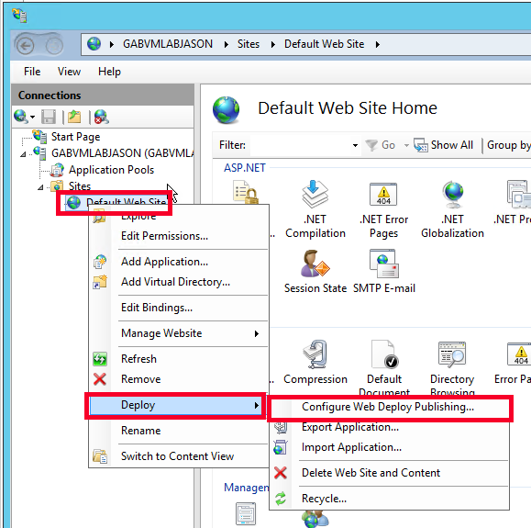

This will open the Configure Web Deploy Publishing dialog.

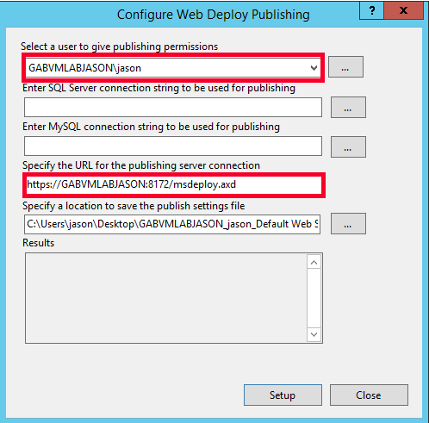

In this dialog, you will need to know the user and the port/path for the publishing.

The next step is to add NSG rules to allow HTTP and WebDeploy traffic to the VM.

# Exercise 4: Configure access for HTTP and WebDeploy ports

In this exercise, you will configure the network security group (NSG) to allow incoming traffic to ports 80 (HTTP) and 8172 (WebDeploy). The DSC script set up the VM but does not add NSG rules – those are outside of the virtual machine.

1. In the Azure Portal, on the virtual machine blade, click on **Network interfaces**.

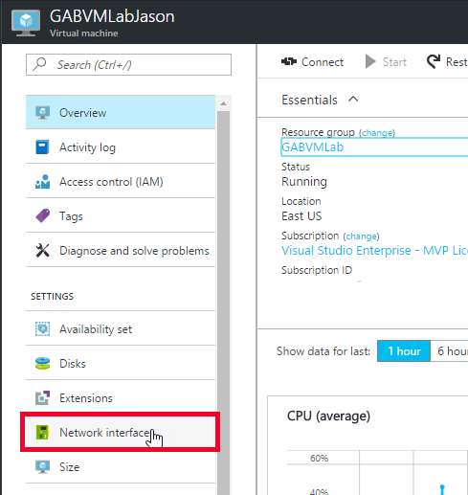

This will open the Network interfaces blade.

1. Click on the name of the network interface

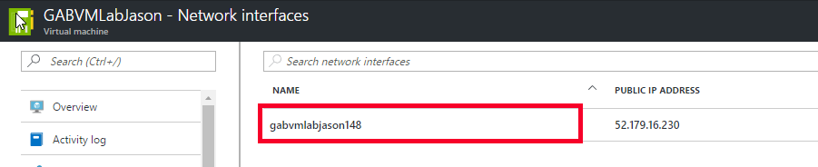

This will open the overview blade.

1. In the listing, find the **Network security group** and click on it

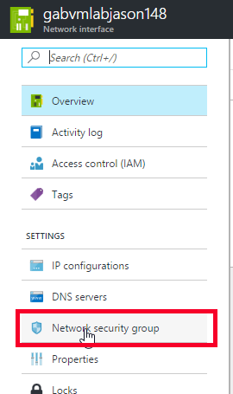

This will show a link to the NSG resource

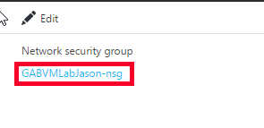

1. Click on the link, to get to the Network Security Group blade
2. In the feature listing, find **Inbound security rules** and click on it

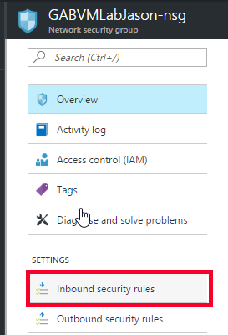

1. Click the **+ Add** button to open the Add inbound security rule blade
2. Fill in the following information to enable HTTP traffic:

* **Name:** Allow_HTTP
* **Priority:** 1010
* **Source:** Any
* **Service:** HTTP
* **Action:** Allow

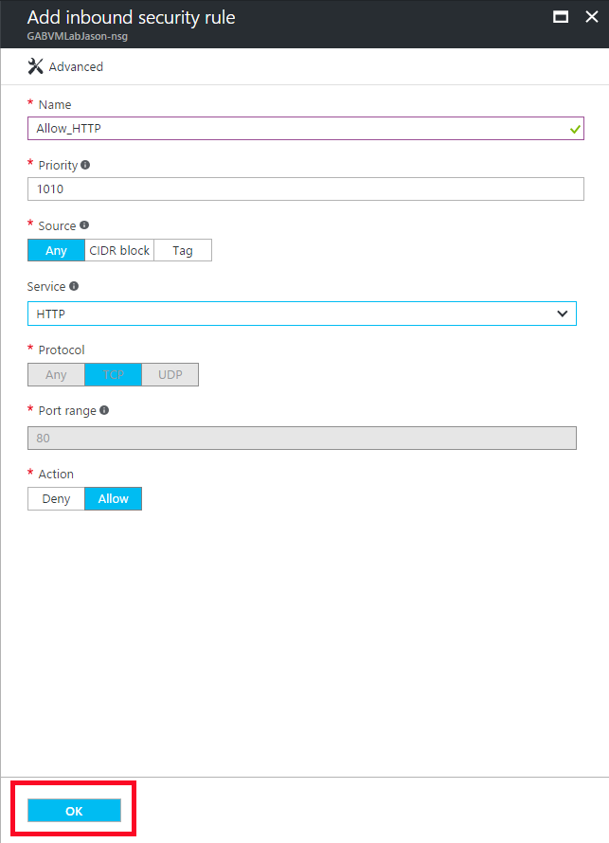

1. Click OK and repeat for the WebDeploy rule:

* **Name:** Allow_WebDeploy
* **Priority:** 1020
* **Source:** Any
* **Service:** Custom
* **Protocol:** TCP
* **Port range:** 8172
* **Action:** Allow

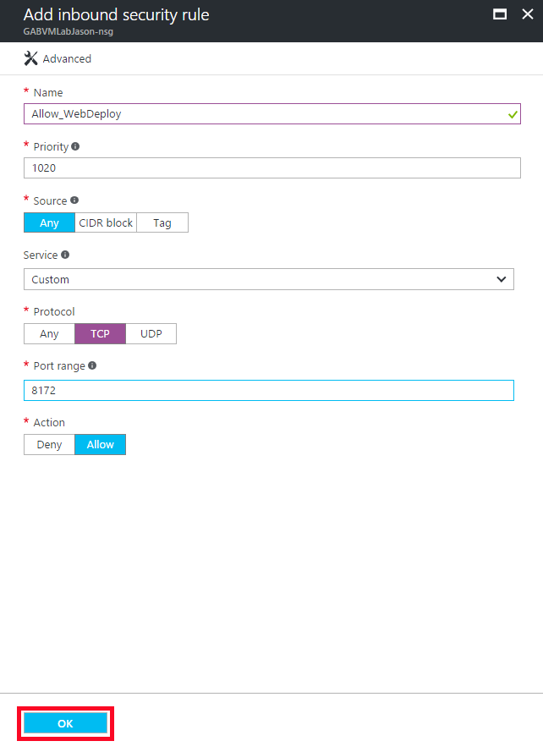

# Exercise 5: Create and deploy sample web application

In this exercise, you will create a sample web application to deploy to the Virtual Machine.

1. Open Visual Studio 2017 Community edition (or greater)
2. File -> New Project

This will show the New Project dialog

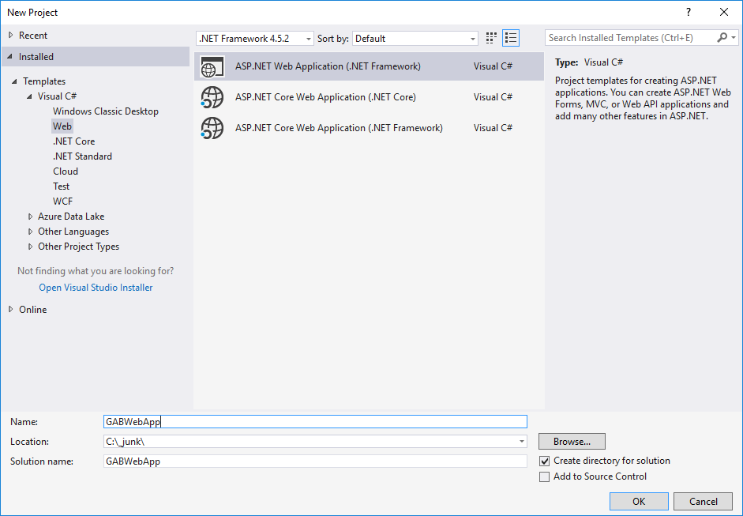

1. Select **Web** from the templates and select **ASP.NET Web Application (.NET Framework)**
2. Give the project a name of **GABWebApp** and select a folder to save the project to
3. Click **OK**

This will show the New ASP.NET Application dialog

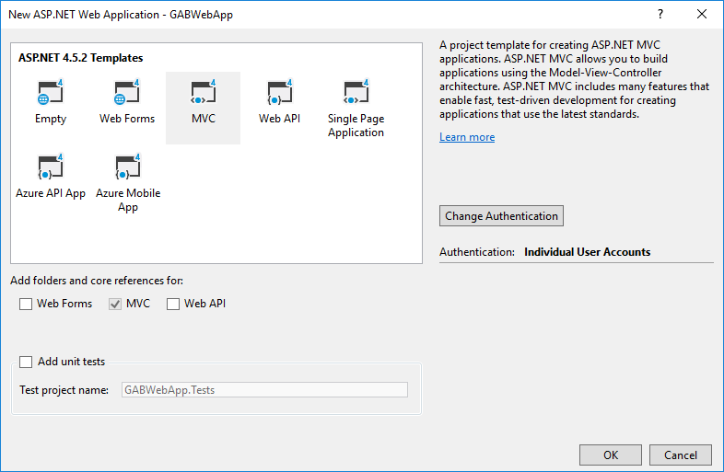

1. Select **MVC** from the template listing and click the **Change Authentication** button

This will show the Change Authentication dialog

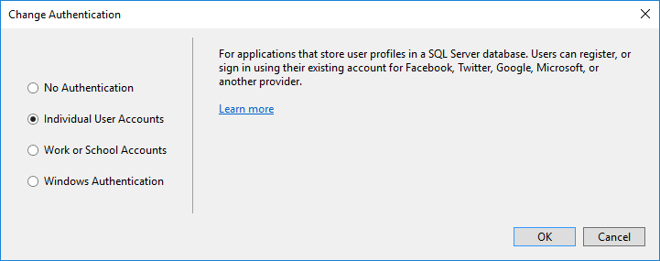

1. Select **Individual User Accounts** (we will connect the signin to a database in a later hands on lab)
2. Click **OK**
3. Click **OK** to create the project
4. Once the project is created, **right click the web project** in the Solution Explorer and select **Publish…**

This will show the new publish interface.

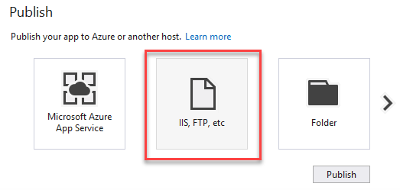

1. Select the **IIS, FTP, etc** button

This will show the Publish wizard

1. Fill in the following in information to configure web deploy for the project:

* **Publish Method:** Web Deploy
* **Server:** https://<your vm public ip address>:8172/msdeploy.axd
* **Server name:** Default Web Site
* **User name:** <your vm name>\<your vm user name>
* **Password:** <your vm password>

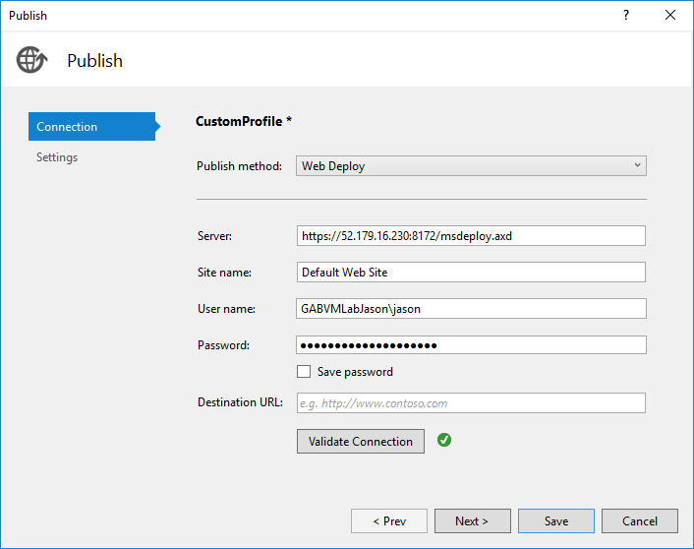

1. Click the **Validate Connection** button to verify the communication to the server is good

This should show the Certificate Error dialog

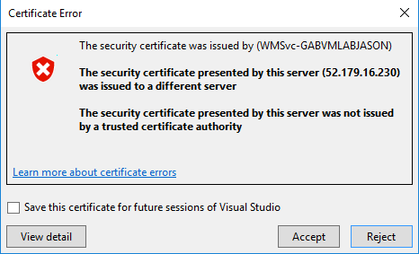

1. Click **Accept**
2. Click **Save**
3. Click **Publish**

This will show the Web Deploy Client dialog

1. Enter your <vm password>
2. Click **OK**

Watch the Output window for the status of the publish. Once you see the publish succeed, open a browser and navigate to the public ip address of your vm and you should see the sample application.

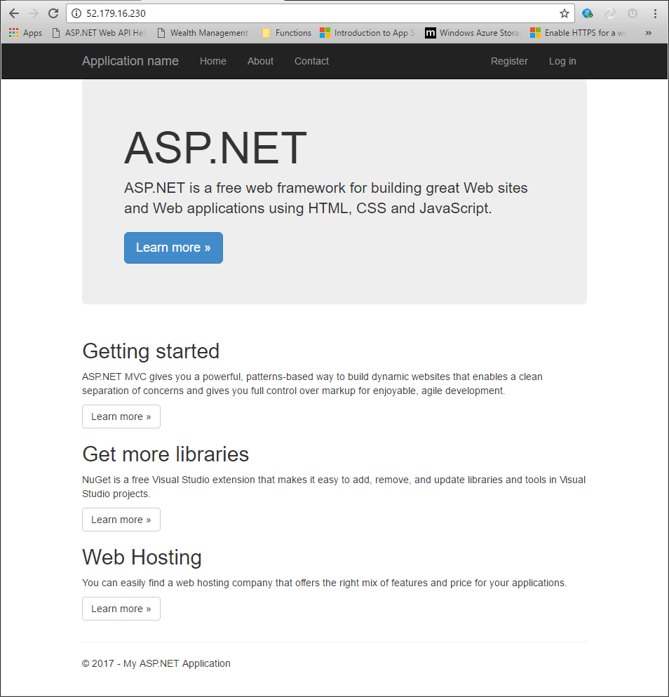

You should now have a web application successfully deployed to your virtual machine using web deploy.

# Exercise 6: Suspend the virtual machine

In this exercise, you will learn how to stop your virtual machine from being charged. You will still be charged for the storage space – but not the compute charges.

1. In the Azure Portal, open the vm blade
2. Click the **Stop** button

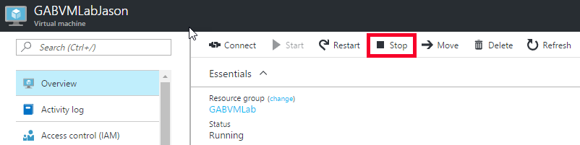

The status of the machine should change from **Running** to **Deallocating**

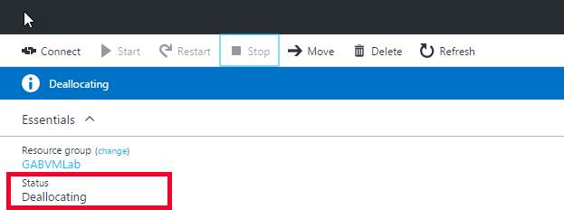

The status s will eventually change to **Stopped (deallocated)**

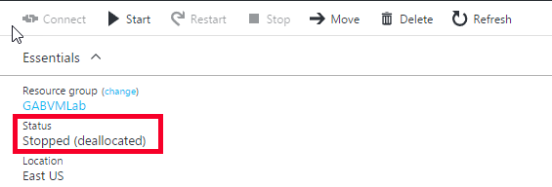

The machine is now just configuration in storage, you will need to click the start button again to be able to access the machine as a Virtual Machine again.